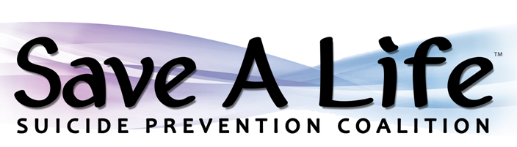
COLOR 5K
Date: Saturday, September 10, 2022 Entry Fee: 5K Registration by 8/31: $25 (Includes T-shirt)
Time: Registration @ 8:00am 5K Registration after 8/31: $30 (No T-Shirt)
1 Mile Fun Run @ 8:30am 1 Mile Kids Fun Run or 1 Mile Walk: $10
5K & 1 Mile Walk @ 9:00am (add $5.00 if pre-ordering shirt by 8/31) Location: Ohio Caverns, 2210 St. Rt. 245 E. West Liberty, Ohio 43357
Virtual option available: If you cannot attend in person, join us in spirit! Use #savealife2022 to help bring awareness to suicide prevention. Pick up your virtual registration t-shirt on 9/9 between 8:30am-4:30pm at the MHDAS Board office 1521 N. Detroit St., West Liberty, Ohio 43357

* Survivors are encouraged to bring a memory board or display to honor their loved one. *
* Awareness Ceremony following the race. *
__________________________________________________________________________________________________

Awards: First 3 Male/Female 5K Finishers Course: Ohio Caverns 5K
First 3 Kids Fun Run Finishers * Course mapped to avoid pasture *
Most Creative “In Memory of” Display
Largest Family/Team Representation
Most Creative Expression/Ensemble Proceeds Benefit Suicide Prevention Coalition

Complete and Detach Registration Below
Saturday, Sept. 10th

Name (Print) _________________________________________________________________

Signature _______________________________________________________________________

Waiver: In consideration of the forgoing, I for myself, my executives, administrators, assignees do hereby release and discharge all sponsors for all claims of damages, demands, actions, and whatsoever, in any manner arising or growing out of my participation in said walk/run. I also give my permission for my photo to be used for social media and promotional purposes.

Address__________________________________________________________________________

City ______________________________________ State_______________ Zip ______________ □ In Person □ Virtual

Phone # _______________________________________ Event (please circle): 5K 1 Mile Kids Fun Run

E-mail _________________________________________ T-Shirt (if registered by 9/1): Adult: S M L XL XXL 3XL
Youth: S M L XL
Make Checks Payable To: Suicide Prevention Coalition
Mail to: MHDAS of Logan & Champaign Counties P.O. Box 765 West Liberty, Ohio 43357
Drop Off at: MHDAS of Logan & Champaign Counties 1521 N. Detroit St., West Liberty, Ohio 43357
TCN Behavioral Health 1522 E. US Hwy 36 Suite A., Urbana, Ohio 43078
118 Maple Ave., Bellefontaine, Ohio 43311
Check or exact cash payment only – staff will not be able to provide change

Contact for Questions: Stephanie Ketchell (937) 631-2883 or sketchell@tcn.org

